Longbenton High School-History department
Year 12 Bridging tasks

Welcome to A level History . This task sheet is designed to prepare you for starting the course in September.
Firstly, we follow AQA specification for A Level.
https://www.aqa.org.uk/subjects/history/as-and-a-level/history-7041-7042/specification-at-a-glance

We study 2 units for examinations and in Year 13 you will submit a Non Examined Assessment ( coursework) which is worth 20% of the final grade-The topic for the NEA is Spain in the 16th Century.
The 2 exam units are:
Unit 1C-A breadth study( covering a long period of history)-The Tudors: England 1485-1603
Unit 2N-A depth study ( covering a shorter period of history)-Russia: from Revolution to Dictatorship, 1917-53
You will be expected to read and prepare for lessons by making notes so these tasks will help you prepare for this type of work. Notes can be made in many ways-mind maps, lists, flow charts, using images etc
We will also watch documentaries and listen to podcasts in preparation for our lessons
We will be referring to this work in our lessons at the start of the A level course-so come prepared!

Unit 1 C: The Tudors: England 1485-1603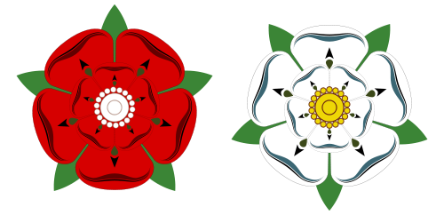

In this unit we will be studying the 5 Tudor monarchs who ruled England and the impact they had. The bridging task is designed to help you understand what had happened in the years before the first Tudor Monarch-Henry VII. This unit is taught by Mrs Skinner.

- The Wars of the Roses
In the decades before Henry VII became king, England had experienced years of unrest and civil war. It saw fighting between rival noble houses in England known as the Wars of the Roses
- Find out who the Roses represent
- Research the Wars of the Roses and complete a mind map to show the major battles, key dates and individuals involved-these websites will be a good starting point, but try and find others yourselves, avoiding Wikipedia!!
- https://www.historic-uk.com/HistoryUK/HistoryofEngland/The-Wars-of-the-Roses/
- https://www.historyextra.com/period/medieval/wars-of-the-roses-york-lancaster-henry-tudor-vi-who-what-when-facts-how-long/

- Richard 111-1483-85 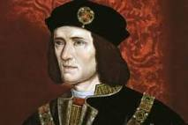
In 1483, after the death of Edward IV, his brother Richard, Duke of Gloucester, became king. Edward did have 2 sons, so Richard becoming king has always been controversial. His 2 nephews ‘disappeared’ and he ruled for 2 years as king of England He died on the battlefield at Bosworth in 1485 and Henry VII became the first Tudor King of England.
- Find out more about Richard 111-character, family, reputation and the mystery of his nephews-these websites etc will be useful
- https://www.le.ac.uk/richardiii/history/whowasrichard.html
- https://www.youtube.com/watch?v=VRIDhxFBHWg
- Create a fact file about the Battle of Bosworth, 1485-key features, why it happened and the outcome of the battle.
- http://www.battlefieldsofbritain.co.uk/battle_bosworth_field_1485.html
- https://www.bbc.co.uk/news/science-environment-30281333
- William Shakespeare wrote a play about this notorious king-if you are interested you can find out more about the play, or even watch it!
- https://www.rsc.org.uk/richard-iii/

- The Tudors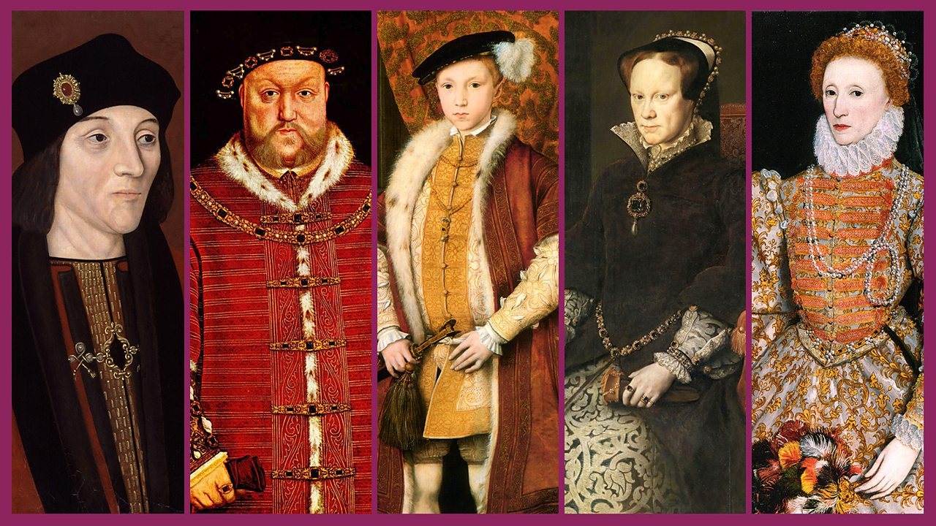
There were 5 Tudor monarchs and we will study them all during Years 12 and 13.
- Create profiles for each Tudor Monarch-use these websites to start you off-
- https://www.royal.uk/tudors
- https://www.historic-uk.com/HistoryUK/HistoryofEngland/The-Tudors/
- The 5 Monarchs were :
- Henry VII-1485-1509
- Henry VIII 1509-1547
- Edward VI 1547-1553
- Mary 1 1553-1558
- Elizabeth 1 1558-1603

Unit 2N - Russia: from Revolution to Dictatorship, 1917-53
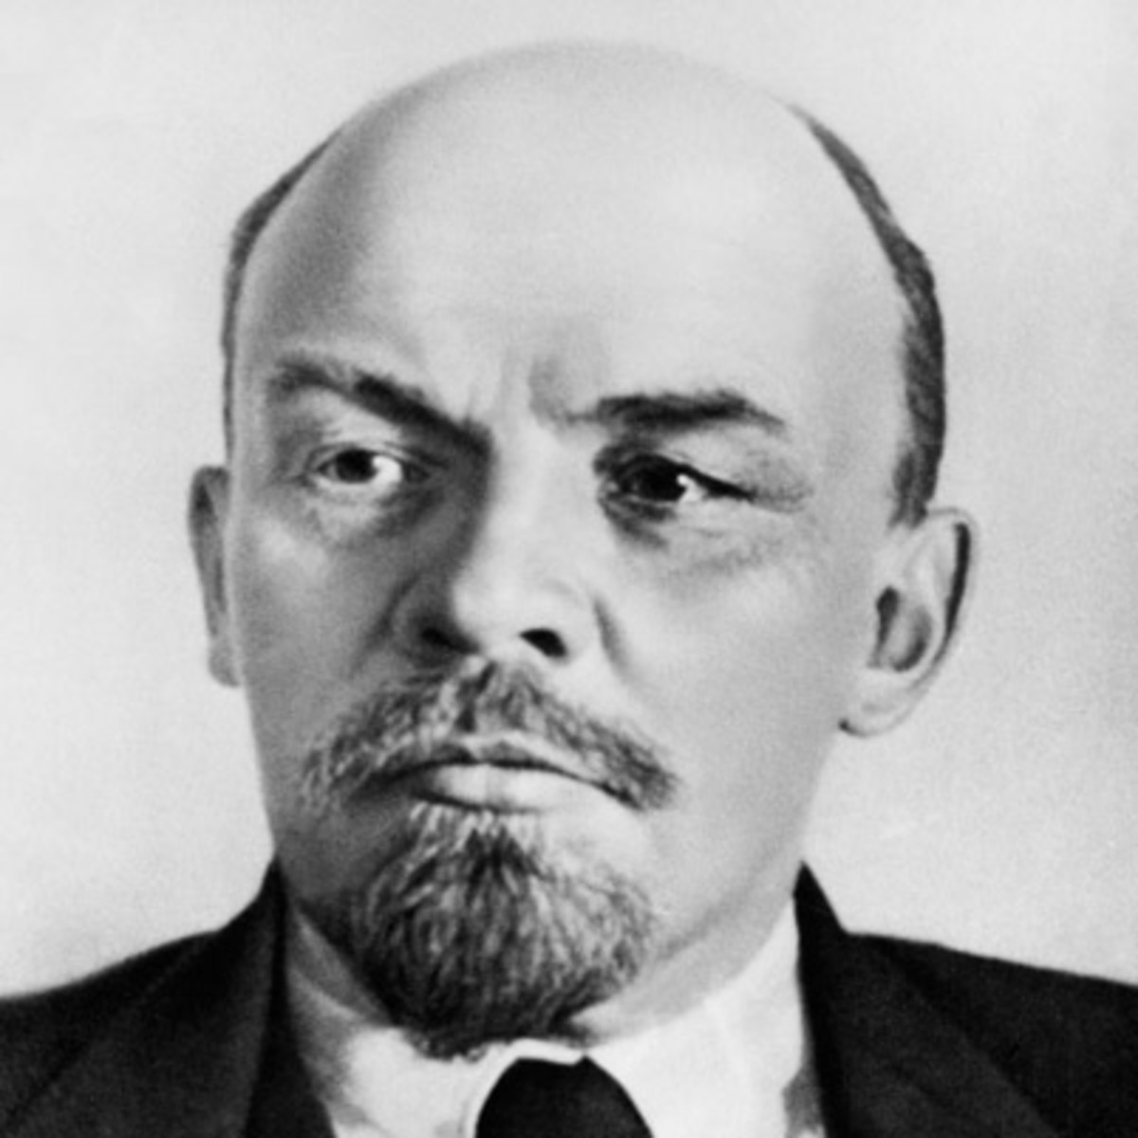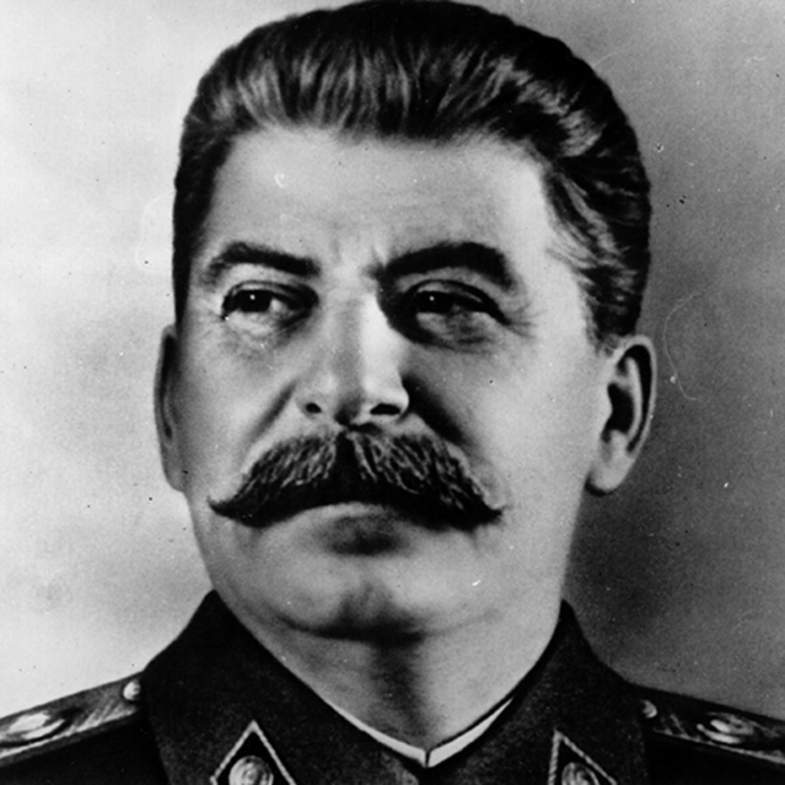

In this unit we will be studying the fall of the Romanov dynasty through the actions of various political factions and wider world events which led to the rise of the Bolshevik Party (Communists) in Russia. Students will study how Vladimir Lenin consolidated the Bolshevik’s control and how this linked to the rise of Joseph Stalin who assumed titles of general secretary of the Communist Party of the Soviet Union and premier of the Soviet Union. The bridging tasks are designed to help you understand what had happened in the years before the 1917 Revolution, and to allow you to begin research on key individuals that will appear throughout the course. This unit is taught by Mr Harold.
Starting point: Tsar Nicholas II and issues that faced Russia
Throughout the 20 years before Nicholas II’s reign came to an end, he faced several challenges at home and abroad. Please see all the video and weblinks (below) as they will help you with your research. I would advise you to make a word document with subtitles for each section.
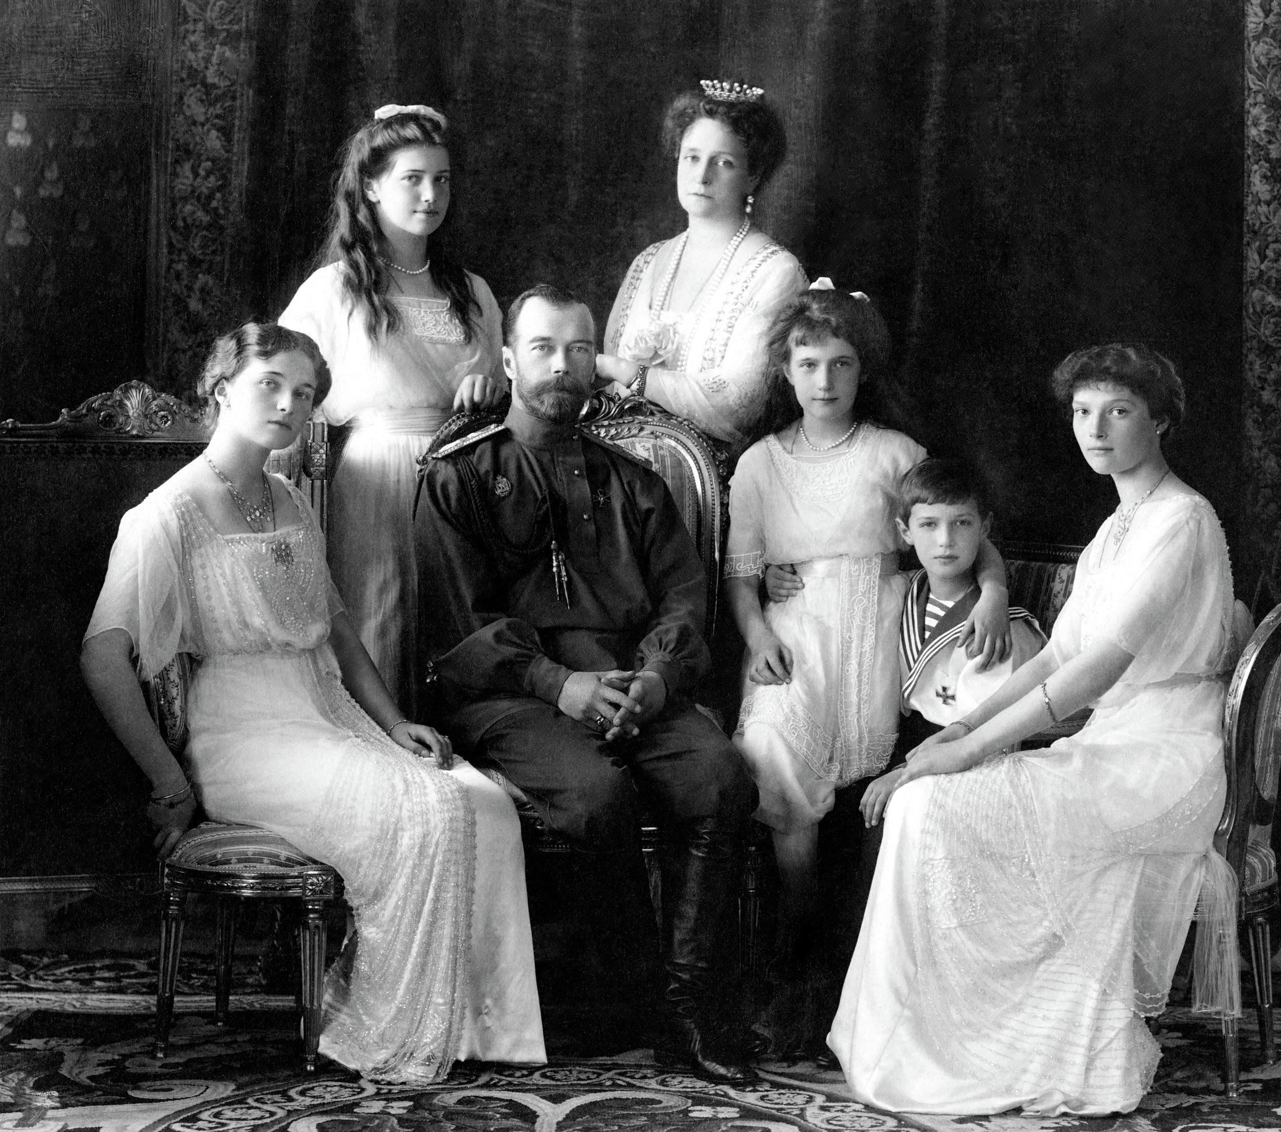
Research the following:
Issues facing the Romanovs in the 1800s (background)
Agriculture and industry before 1914
The role of the Russian Orthodox Church and how it links to Tsar Nicholas II?
Russo-Japanese war (1904-5)
https://www.youtube.com/watch?v=qS1csqutxv4 (Russo-Japanese War | 3 Minute History)
1905 Russian Revolution
Russia’s involvement in World War One
The role of Grigori Rasputin
https://www.youtube.com/watch?v=dP5C59QTuKI (The Real Rasputin (Imperial Russia Documentary) | Timeline)
What happened to Nicholas and his immediate family?
https://www.youtube.com/watch?v=2pnEGmjDOSY (The Riddle of the Romanovs - Royal murder mysteries)

Key people/ terms to research:
Tsar Nicholas II of the Romanov family (and how Alexander II and Alexander III link to him).
Karl Marx and Friedrich Engels – what is Marxism? What is Communism?
What is a Menshevik?
What is a Bolshevik?
Pavel Nikolayevich Milyukov
Alexander Kerensky
Sergei Witte
Pyotr Stolypin
Grigori Rasputin
Vladimir Lenin
Leon Trotsky
Lev Kamenev
Gregory Zinoviev
Nikolai Bukharin
Felix Dzerzhinsky
Joseph Stalin

Useful weblinks for the course:
https://spartacus-educational.com/Russia.htm
The Spartacus website is useful for general background research. The most important for this bridging unit is the section ‘Russian Rulers and Dictators’. For example, in the Nicholas II section there are several subsections which include Grigori Rasputin.
http://www.orlandofiges.info/section1_OriginsoftheRussianRevolution/index.php
Orlando Figures’ specialism is Russian History. On his website he has a free summary of Russia in the Twentieth Century. The most important sections for the bridging unit is Section 1-4 (1905-17).

